STATE-SPACE MPC QUICKSTART GUIDE

Syntax: [mpv, online] = ss2qp(mpc, ss)

SS argument: state space model

The usual linear discrete time state space model (LTI) equations:

x(t+1) = Ax(t) + Bu(t) + Cd(t)
y(t) = Dx(t) + Eu(t) + e

The only notable exception is d, the vector of measured disturbances (inputs that we have no direct control upon). The term e is the process model mismatch, an optional feature that will be discussed below.$e=\hat{y}(0)−y(0)$, the difference between real (measured) minus the predicted output at time t=0.

MPC argument: definition of MPC control

This is a struct matlab variable, with most members optional. Depending on what you define, you turn on/off various options for the MPC transformation. The generic optimization problem solved is:

$$\underset{x,y,u}{\text{min}}J=x'_{N}{\text{Px}}_{N}+\sum_{k=1}^{N−1}{x_{k}Q_{k}x_{k}+}\sum_{k=1}^{N−1}{(y_{k}−y_{k}^{R})'{\text{QR}}_{k}}(y_{k}−y_{k}^{R})+\sum_{k=0}^{M−1}{(u_{k}−u^{R})'R_{k}(u_{k}−u^{R})+\sum_{k=0}^{M−1}{{Δu}_{k}R1_{k}{Δu}_{k}}}$$
Be careful with the timing of various discrete intervals k for the summations! Time starts at k=0 where we know the plant state x₀ and can measure the plant output y₀. The control action in the first interval u₀ is an optimization variable. The prediction horizon is N and control horizon M (usually smaller). See the figure below:
k=0
k=1
k=M-1
k=N-1
Control horizon (M variables)
Output horizon (N stages, N-1 variables)
Only x_{N}
(terminal weight)
The usual terminology is used, ie x are states, y outputs and u controls. All are (discrete) time dependent vectors. The subset of output variables that get tracked have time-dependent setpoints y^{R}. Finally Δu are changes in control variables, Δu(k) = u(k) - u(k-1). Note Δu(0) requires the last control action u(-1) which becomes an extra parameter whenever you use the Δu formulation.

Whenever the control horizon is shorter than the prediction horizon, all later controls remain fixed, i.e. u(M-1) = u(M) = … = u(N-1). @@@ in the future we may have stabilization terms

You can selectively leave terms out of the objective function just by not defining the respective quadratic term. So if you don’t define mpc.Q field, there won’t be state terms in the objective.

There are a few ways you can define these quadratic coefficients. Say you have 2 controls u and an output horizon of N=2 then the following are all valid definitions of the control table R:

mpc.R = [2 3]; % scaling factors, same across horizon
mpc.R = [2 -1; -1 3]; % single period matrix, enables off-diagonal terms
mpc.R = [2 3 4 5]; % scaling factors, one set per time interval
mpc.R = [2 0 0 0; 0 3 0 0; 0 0 4 0; 0 0 0 5]; % matrix version of above for all horizon

Note that this format enables different weight matrices across the horizon.

Control move blocking
A method to decrease the number of optimization variables and the numerical complexity is move blocking, where a control level is applied for successive time intervals, effectively keeping it constant. This setting affects all the controls; it’s not possible to have different blocking per individual control variable. The easiest way to do move blocking is with mpc.uzip. eg

mpc.uzip = 2; % 2 successive controls are blocked, ie u(0)=u(1), u(2)=u(3) etc

If you want to set irregular intervals, use the more robust u_bundle field, grouping the time intervals in a cell array, e.g. for a control horizon M=3

mpc.u_bundle = {[1,3], [2]}; % u(0)=u(2), u(1) free (index 1 corresponds to time 0…)

Variable input reference
You can define if an input has reference value ( appears as a parameter). The field mpc.uRef is the main setting for this option.
mpc.uRef=[NaN 1 0];
In this case only use the first input as parameter and tries to fix the values of the second and third to 1 and 2 respectively.
Note that if we use the option mpc.uRef , we need to add references values of all the inputs, and this references value will be for the entire control horizon. In case we prefer to leave some inputs without reference we have to transform the matrix R accordingly ( zero the values of input we want to leave free).

Variable state reference
ss2qp doesn’t have the option for reference values in state variables, but we can overcome that by changing matrix mpc.D in order to make all the state variables, output variables.

Variable output tracking
You can control which outputs appear in the objective, and the type of tracking. The field Ysp_Idx is the main setting, holding the indices of the outputs to be tracked:

mpc.Ysp_Idx = [ 2 ]; % only track the 2nd output (as appears in SS model)

All the remaining tracking parameters, including the quadratic coefficient QR (objective function) are anchored to Ysp_Idx. E.g. you shouldn’t add weights for non-tracked output variables in QR.

By default a single setpoint is added as a parameter, which is assumed constant over the output horizon [1->N-1]. It is possible to set bundling properties per output (unlike control move blocking) using the optional field Ysp_Mode, e.g. for N=4:

mpc.Ysp_Mode{1} = {[1] [2] [3]}; % a different setpoint for 1st output at each point
By default each setpoint introduces a new parameter, but it is possible to use another optional field to fix setpoints for particular outputs, called Ysp_Val. This should have the same number of entries as Ysp_Mode with values specifying the requested fixed setpoint value e.g for the vector above:

mpc.Ysp_Val{1} = {6,8, nan}; % fixed setpoints for intervals 1-2 and parameter for 3

Note the use of matlab’s NaN number to denote the free parameter, and specific fixed setpoint values otherwise.

Constraint control
Optionally each input, output and other variables can be constrained, either from below or above. The bound can be a specific hard coded number or a free parameter (same across all prediction horizon). It’s best to illustrate the capability with specific examples:

mpc.Xmax = [2 2];  mpc.Xmin = [-1 -1]; | Two states, upper bound 2 and lower bound -1
mpc.Xmax = [2 nan];  mpc.Xmin = [-1 inf]; | First state same as above, second state parametrically bound from above and unbounded from below i.e.  $$−∞≤x_{2}≤θ$$

Again note the use of NaN symbol for free bounds and matlab’s INF for infinity (unbounded). The bounds normally apply to all horizons but it is possible to turn off specific time intervals for all variables using ?nocon fields, e.g for N=5:

mpc.Xnocon = [2 3]; % 2nd and third period states unconstrained, 1,4 & 5 constrained

Process model mismatch
A simple way to eliminate steady state offsets for output variables. At the beginning of the prediction horizon, we know/estimate the state x(0) and can measure the real output $\hat{y}(0)$so we can estimate the process model mismatch as:
$$e=\hat{y}(0)−y(0)=\hat{y}(0)−\left(\text{Cx}(0)+\text{Du}(0)\right)$$
The optional field Ymismatch declares the indices of outputs that feature mismatch. Typically it is aligned to Ysp_Idx field for tracking but it should be mainly declare outputs that are known to be mispredicted.

mpc.Ymismatch = [1 2]; % output indices where we apply process-model mismatch

One parameter per output is introduced (constant for all prediction horizon). The measurement itself $\hat{y}(0)$ is the parameter – you don’t have to calculate the initial error.
@@@add integrators

The following table lists all the fields supported in the MPC argument, and they are mostly optional as explained above

Field | Description
OH | Output horizon (N)
NC | Control horizon (M)
Q | Objective coefficient for states (x)
P | Terminal weight matrix for states (t=N)
QR | Quadratic matrix for tracked outputs (y)
pYmul | Scalar adding more terminal weight for the last interval (pYmul*QR) to force output setpoints to be met
R | Quadratic matrix for manipulated variables (u)
R1 | Weight matrix for output moves (Δu)
Umax | Upper bound vector for inputs; NaN/Inf supported
Umin | Lower bound vector for inputs
Unocon | Subset of control horizon where inputs U are unconstrained
Xmax | Upper bound vector for states; NaN/Inf supported
Xmin | Lower bound vector for states
Xnocon | Subset of output horizon where states X are unconstrained
Ymax | Upper bound vector for outputs; NaN/Inf supported
Ymin | Lower bound vector for outputs
Ynocon | Subset of output horizon where outputs Y are unconstrained
YsoftP | Penalty coefficient (positive), turns on output constraint softening, adds extra slack variable in objective function
DUmax | Upper bound vector for input changes; NaN/Inf supported
DUmin | Lower bound vector for input changes
DUnocon | Subset of control horizon where input changes ΔU are unconstrained
bFixedDisturbance | When measured disturbances d are present in the SS model, by default the disturbance introduces one extra parameter per time period (time varying). Setting this field to 1 freezes the disturbances at their initial levels, reducing the number of parameters
uzip | Control move blocking width, in number of consecutive time intervals
u_bundle | Cell array with customized blocking intervals for all outputs
Ymismatch | Which output indices are subject to process model mismatch
Ysp_Idx | Indices of tracked outputs
Ysp_Mode | Setpoint blocking cell array per output (similar to u_bundle)
Ysp_Val | Same in structure as Ysp_Mode; NaN for free setpoint or specific number for fixed setpoint
uRef | Reference point for the input variable
MPV return: structure to be passed to mpqpX solver

This contains the equivalent mpQP formulation that corresponds to the MPC problem, already in Z formulation (i.e. the controls U have been substituted with Z so as to eliminate bilinear U*θ terms from the objective function).
$$\begin{aligned}J(θ)=\underset{z}{\text{min}}\frac{1}{2}z'\text{Hz}+\text{Lz} \\ s\text{.}t\begin{matrix} & \end{matrix}\text{Az}≤b+Sθ\end{aligned}$$

All the equations (state space look-ahead) have been eliminated and the constraints reproduced for all future time intervals. Redundant inequalities have been removed and the only extra information required for the multiparametric solver is the range of parameters to search $\left[ϑ_{\text{min}},ϑ_{\text{max}}\right]$.

After the successful calculation of the explicit control law, don’t forget to do the reverse transformation from Z->U, as in the examples below.

ONLINE return: contains online controller version and information

In the interest of clarity and cross validation, the second returned struct contains the “online” version of the explicit controller that can be used with a standard QP solver for a second opinion or for a quick way to screen alternative MPC controller tuning parameters without deriving the explicit form (which can be time consuming). The most important fields can be used to construct the following QP optimization (note it is in raw U mode, not involving Z transformation):
$$\begin{aligned}J(θ)=\underset{u}{\text{min}}\frac{1}{2}u'\text{Hu}+\left(θ'F+U_{\text{lin}}\right)u+\underset{\text{cons}\text{tan}t\begin{matrix} & \end{matrix}\text{terms}}{\underbrace{θ'\text{TT}θ+T_{\text{lin}}θ+c}} \\ s\text{.}t\begin{matrix} & \end{matrix}\text{Au}≤b+Sθ\end{aligned}$$
If you need to reconstruct the dependent variables of the MPC (states, outputs etc) you can do so via the system of equations in online.L field, which is a composite matrix with the coefficients to the equation:
$${\text{Ix}}_{D}+L_{1}x_{F}+L_{2}θ_{1}+c=0⇒x_{D}=−L_{1}x_{F}−L_{2}θ_{1}−c$$
where x_{D} and x_{F} are the dependent and free variables respectively, θ₁ are the parameters associated to the state-space model and c is a constant column. The names of the variables and parameters are also returned for your convenience in fields namesVars, namesFree and namesTheta. The θ₁ are the first nuT1 entries of namesTheta, followed by nuT2 parameters associated with input setpoints (@@@ not implemented yet!) and finally nuT3 parameters for min-max bounds. As an extra complication, the order of columns (variables) in L matrix may be changed as a result of the gaussian elimination (compared to namesVars vector) and this order can be found in online.xid field.

Finally online.P field is required for the reverse transformation from Z->U according to the following rule:
$$z=u+\underset{}{\underbrace{H^{−1}F'}}θ=u+Pθ⇒u=z−Pθ$$

EXAMPLES

These simple matlab scripts demonstrate simple and more advanced MPC problems through ss2qp

% TEST1.m ----------------------------------
% the classic example in first mpQP paper (bemporad et al 2002)

clear mpc ss; % wipe old definitions

% state space model: two states, one control and one output
% x(+1) = Ax + Bu + Cd (here no measured disturbance d)
ss.A = [0.7326 -0.0861; 0.1722 0.9909];
ss.B = [0.0609 ; 0.0064 ];
ss.D = [0 1.4142]; % y = Dx + Eu

mpc.OH = 2; % output horizon
mpc.NC = 2; % control horizon
% objective: min xPx + SUM(xQx) + SUM(uRu)
mpc.Q = eye(2); % scaling for states
mpc.R = 0.01; % incorporates "rho" move suppression term
mpc.P = [3.0485 -2.5055; -2.5055 12.9916]; % terminal weight
mpc.Umax = [2];
mpc.Umin = [-2];
% all remaining variables unconstrained

[mpv, online] = ss2qp(mpc, ss); % transform into mpQP

nt = online.nParam;
t_low= -2 * ones(nt,1);
t_up= 2 * ones(nt,1);
cr = bound2Constr(t_low, t_up); % parameter search space [-2,2]

cr2 = mpQP2(mpv, cr); % get explicit controller
CRInf = cr2;
for ik=1:length(cr2);
% inverse Z transformation
CRInf(ik).X = cr2(ik).X - [online.P zeros(length(online.ULin),1)];
end

dispQPSolution(CRInf);
plotCRinfo2D(CRInf);

solution:

---------- Feasible region 1 ----------
x1 = +2
x2 = -4.44089e-016*t1 +8.88178e-016*t2 -2
+1*t1 +0.731198*t2 <= -0.211641
-0.735597*t1 +1*t2 <= -0.294185
-1*t1 <= +2
-1*t2 <= +2
---------- Feasible region 2 ----------
x1 = -6.41479*t1 -4.69048*t2 +0.642364
x2 = +1.77636e-015*t2 -2
-1*t1 -0.731198*t2 <= +0.211641
+1*t1 +0.731198*t2 <= +0.411917
-0.225292*t1 +1*t2 <= -0.293035
-1*t2 <= +2
---------- Feasible region 3 ----------
x1 = +8.88178e-016*t1 +2
x2 = -3.41514*t1 +4.64268*t2 -0.634191
-0.735597*t1 +1*t2 <= +0.567385
+0.735597*t1 -1*t2 <= +0.294185
+0.860277*t1 +1*t2 <= -0.290588
-1*t1 <= +2
---------- Feasible region 4 ----------
x1 = -2
x2 = -4.44089e-016*t1 +8.88178e-016*t2 -2
-1*t1 -0.731198*t2 <= -0.411917
-0.735597*t1 +1*t2 <= -0.567385
+1*t1 <= +2
-1*t2 <= +2
---------- Feasible region 5 ----------
x1 = -5.92093*t1 -6.88259*t2 +0
x2 = -1.53765*t1 +6.82512*t2 +0
-0.860277*t1 -1*t2 <= +0.290588
-0.225292*t1 +1*t2 <= +0.293035
+0.860277*t1 +1*t2 <= +0.290588
+0.225292*t1 -1*t2 <= +0.293035
---------- Feasible region 6 ----------
x1 = +2
x2 = -4.44089e-016*t1 +8.88178e-016*t2 +2
+1*t1 +0.731198*t2 <= -0.411917
+0.735597*t1 -1*t2 <= -0.567385
-1*t1 <= +2
+1*t2 <= +2
---------- Feasible region 7 ----------
x1 = +8.88178e-016*t1 -2
x2 = -3.41514*t1 +4.64268*t2 +0.634191
-0.735597*t1 +1*t2 <= +0.294185
+0.735597*t1 -1*t2 <= +0.567385
-0.860277*t1 -1*t2 <= -0.290588
+1*t1 <= +2
---------- Feasible region 8 ----------
x1 = -6.41479*t1 -4.69048*t2 -0.642364
x2 = +1.77636e-015*t2 +2
-1*t1 -0.731198*t2 <= +0.411917
+1*t1 +0.731198*t2 <= +0.211641
+0.225292*t1 -1*t2 <= -0.293035
+1*t2 <= +2
---------- Feasible region 9 ----------
x1 = -2
x2 = -4.44089e-016*t1 +8.88178e-016*t2 +2
+0.735597*t1 -1*t2 <= -0.294185
-1*t1 -0.731198*t2 <= -0.211641
+1*t1 <= +2
+1*t2 <= +2
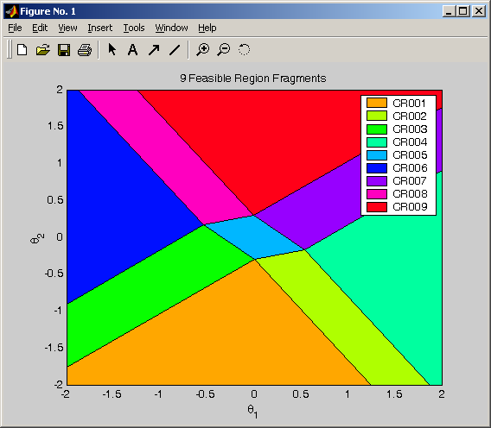

% TEST2.m ----------------------------------
% contrived example highlighting setting up the MPC problem
clear mpc ss;

% state space model including measured disturbance
% 2 states, 2 outputs, 4 controls and 3 disturbances
% x(+1) = Ax + Bu + Cd
ss.A = [0.7326 -0.0861; 0.1722 0.9909];
ss.B = [0.0609 1 2 3; 0.0064 0 0 -1];
ss.C = [1 2 3; 4 5 6]; % disturbance term
% y = Dx + Eu
ss.D = [0 1.4142; 1 0];
ss.E = [-1 0 1 0; 1 0 -1 1];

mpc.OH = 5; % output horizon
mpc.NC = 3; % control horizon (shorter)
% objective: min x’Px + SUM(x’Qx) + SUM(Du’R1Du) + SUM(y-ySP)’QR(y-ySP)
mpc.Q = eye(2); % weights for states
mpc.QR = [3 2]; % for outputs
mpc.R1 = 10*ones(1,4); % for Du; nothing for plain U! (no mpc.R)
mpc.P = [3.0485 -2.5055; -2.5055 12.9916]; % terminal weight
mpc.Umax = 2*ones(1,4);
mpc.Umin = -2*ones(1,4);
mpc.Xmax = [2 nan]; % x2 upper bound is a parameter
mpc.Xmin = [-1 inf]; % x2 is lower-unconstrained
mpc.Xnocon = [1]; % first period unconstrained for X
mpc.uzip = 2; % first block u(0)-u(1), second u(2) solo
mpc.bFixedDisturbance = 1; % d remains at d(0) levels for all horizon
mpc.Ymin = [nan 0]; % first output low bound is parameter; no upper bounds!
mpc.Ynocon = [2]; % output is unconstrained for interval #2
mpc.DUmax = [100 100 100 100]; % fixed upper bounds for control moves
mpc.DUmin = [inf 0 -1 inf]; % Du bounds not exist for Du1 and 4 (all times)
mpc.Ymismatch = [1]; % output indices where we apply process-model mismatch
mpc.Ysp_Idx = [1 2]; % indices of tracked outputs (all)
mpc.Ysp_Mode{1} = {[1] [3] [4] [2]}; % pointless but showing off flexibility
mpc.Ysp_Mode{2} = {[1:3], [4]}; % first 3 setpoints for y2 are the same
mpc.Ysp_Val{1} = {6, 7, 8, nan}; % y1 setpoints #1,3,4 fixed at given levels
mpc.Ysp_Val{2} = {nan, 5}; % y2 first setpoint group is parameter, 4th fixed

[mpv, online] = ss2qp(mpc, ss); % transform into mpQP
% don’t bother with solution, we have 30000+ critical regions!

Although we don’t attempt to solve the second example (14 parameters, 30000+ regions!) we get some interesting information from the online struct returned by ss2qp. The most important is the constitution of the parameter vector:

online.namesTheta =
x1(t) x2(t) u1(t-1) u2(t-1) u3(t-1) u4(t-1) d1(t+0) d2(t+0) d3(t+0) y1(t)_real y1(t+2)_SP y2(t+3)_SP xMax2 yMin1

The first group θ₁ is parameters introduced by the equality constraints, namely current states x_{i}(t=0), the previously calculated controls u_{i}(t-1) – that’s due to the Δu formulation – the present disturbances d_{i} and the current (real, measured) level of y₁, the result of mpc.Ymismatch. The second group θ₂ (currently merged with θ₁) comes from the objective and the combined effect of Ysp_Idx (both outputs tracked) and Ysp_Mode. On its own it declares 4 separate setpoints for y₁ and 2 for y₂ so we would have 6 parameters in this group, but we fixed four of them (y₁(t+1)=6, y₁(t+3)=7, y₁(t+4)=8, y₂(t+4)=5) so we are left with the remaining 2: y1(t+2)_SP and y2(t+3)_SP (equivalent to y2(t+1)_SP). The final group θ₃ stems for the 2 NaNs in the bound declarations for x₂max and y₁min.

The other important vector is that of the free optimization variables, which is the order of rows in the solution CRInf(i).X (theta are the columns plus a constant term)
online.namesFree =
u1(t+1) u2(t+1) u3(t+1) u4(t+1) u1(t+4) u2(t+4) u3(t+4) u4(t+4)

Since we have mpc.NC=3 control horizon length and 4 u’s we would expect 12 free variables, but here u_{i}(t)= u_{i}(t+1) due to the blocking introduced by mpc.uzip. Confusingly, u_{i}(t+4) is reported as the second free group instead of the more straightforward u_{i}(t+2) according to the end of the control horizon, but mathematically they are the same since past NC controls remain unchanged. Likewise u(t+1)=u(t) due to forced blocking. U(t) is the one we would use for the online MPC implementation (all future control actions are ignored online so they needn’t be stored!)

In case we needed to reconstruct the full variable vector, here are the order of the variables:
online.namesVars =
Columns 1 through 10
'Du1(t+0)' 'Du2(t+0)' 'Du3(t+0)' 'Du4(t+0)' 'Du1(t+1)' 'Du2(t+1)' 'Du3(t+1)' 'Du4(t+1)' 'Du1(t+2)' 'Du2(t+2)'
Columns 11 through 20
'Du3(t+2)' 'Du4(t+2)' 'Du1(t+3)' 'Du2(t+3)' 'Du3(t+3)' 'Du4(t+3)' 'Du1(t+4)' 'Du2(t+4)' 'Du3(t+4)' 'Du4(t+4)'
Columns 21 through 31
'y1(t+1)' 'y2(t+1)' 'y1(t+2)' 'y2(t+2)' 'y1(t+3)' 'y2(t+3)' 'y1(t+4)' 'y2(t+4)' 'x1(t+1)' 'x2(t+1)' 'x1(t+2)'
Columns 32 through 42
'x2(t+2)' 'x1(t+3)' 'x2(t+3)' 'x1(t+4)' 'x2(t+4)' 'x1(t+5)' 'x2(t+5)' 'u1(t+0)' 'u2(t+0)' 'u3(t+0)' 'u4(t+0)'
Columns 43 through 53
'u1(t+1)' 'u2(t+1)' 'u3(t+1)' 'u4(t+1)' 'u1(t+2)' 'u2(t+2)' 'u3(t+2)' 'u4(t+2)' 'u1(t+3)' 'u2(t+3)' 'u3(t+3)'
Columns 54 through 58
'u4(t+3)' 'u1(t+4)' 'u2(t+4)' 'u3(t+4)' 'u4(t+4)'

The naming convention for all input/state/etc variables is u_{j}(t+k), j denoting the order of the variable in the state-space model matrices, and k the time step from the beginning of the prediction horizon.

Finally here’s a short matlab script that demonstrates how to cross-validate explicit and online MPC solutions (see test1.m above again for matlab variable names). This also demonstrates how you can use the online MPC controller without the explicit version (left as an exercise ☺)

nt = online.nParam;
trag = t_up - t_low; % variation range for parameters
ZERO = sqrt(eps);

for i=1:1000
t = t_low + trag.*rand(nt,1); % random theta
disp(t');

% solve a straight QP optimization, note linear term for U
[U,Lm,HOW] = qp(online.H, (online.ULin + t'*online.F)', online.A, ...
online.b + online.S*t);
feas1 = strcmp(HOW, 'ok');

% compare this with the parametric solution
idx = locateCR(CRInf, t);
feas2 = idx > 0;
if feas1 == feas2
if feas1
x2 = CRInf(idx).X(:,1:nt)*t + CRInf(idx).X(:,end);
tol = max(abs(U));
if tol > 1, tol = ZERO*tol;
else tol = ZERO;
end

if any(abs(U-x2) > tol)
error('control disagreement');
end
% else both infeasible, check!
end
else
fprintf('feasibility disagreement: %d %d\n', feas1, feas2);
end
end

HOW TO DO SIMULATIONS?

A generic simulation matlab script is not provided since there are infinite permutations of the theta vector with setpoints etc. However, it is not difficult to write a simulation script for each parametric controller case, based around the following skeleton. It uses two sets of everything (variables, state space models etc), one for the “plant” and one for the controller, so it is possible to investigate process-model mismatch issues.

% PREVIOUSLY DEFINED VARIABLES
% ss: state space model used to derive controller
% CRInf: explicit controller

% starting x value (_m for model, _p for plant)
xm = zeros(size(ss.B, 1), 1);
xp = xm; % plant state

if isfield(ss, 'C') & norm(ss.C, 'inf') > eps
error('you must modify this script to handle measured disturbance');
end
if ~isfield(ss, 'E'), ss.E = zeros(size(ss.D,1), size(ss.B,2)); end

plant = ss;
plant.A = [ 1.4 -0.46 % steady state gain
1 0];

% matrices that hold the evolution of plant state etc over time
% column 1 is for time=1, column 2 for time=2 and so on
yp = plant.D*xp;
ym = ss.D*xm;
u= [];

range = 1:50; % simulation horizon
for i=range
x0 = xm(:,end);
% parameters are: [x1(t) x2(t) y1(t)_real y1(t+2)_SP]
t = [x0; plant.D*xp(:,end); 1];
if i>30, t(end) = -1; end % simulate setpoint change

idx = locateCR(CRInf, t); % lookup optimal control region
if 0==idx, error('infeasible!'); end

% calculate optimal control
u0 = CRInf(idx).X(:,1:nt)*t + CRInf(idx).X(:,end);
u = [u u0];
y0 = ss.D*x0 + ss.E*u0;
ym = [ym y0];
x1 = ss.A*x0 + ss.B*u0;
xm = [xm x1];

% nudge "real plant"
x0 = xp(:,end);
y0 = plant.D*x0 + plant.E*u0;
yp = [yp y0];
x1 = plant.A*x0 + plant.B*u0;
xp = [xp x1];
end

figure
subplot(211);
plot(range,yp(range));
grid

subplot(212); grid
stairs(range,u(range));
grid

The “tricky” bit is maintaining the parameter vector at each prediction point. You have to consult online.namesTheta for your situation to determine the composition and the order of the parameters.

In the example above, parameters are the plant states, the “real” output value and its desired setpoint. Pay attention above how the t vector is constructed! Also notice how mid-time in the simulation the setpoint is switched from 1 to -1.
Example for uRef

When the problem doesn’t include uRef the tuning, most of the times, is easy since the objective is to approach the desired value of the tracked output, keeping the inputs and/or input changes as small as possible. However, if we introduce uRef means that we want a specific value for the input and the tuning is becoming the main factor in order to achieve the desired values of uRef without losing the output tracking.
The following example illustrates this issue.
The first part is the extraction of multi-parametric solution.
% state space model: two states, one control and one output
% x(+1) = Ax + Bu + Cd (here no measured disturbance d)
% y=Dx+Eu
ss.A=[1 1;0 1];
ss.B=[0 1 2; -1 0 0];
ss.D=[1 0; 2 -1];
ss.E=[0 1 0; -1 0 0];
mpc.OH = 5; % output horizon
mpc.NC = 2; % control horizon
% objective: min xPx + SUM(xQx) + SUM(uRu)
mpc.Q = 1*[1 0;0 0]; % scaling for states
mpc.R = 0.00001*eye(3);
mpc.R1 = 0.1*eye(3);
mpc.QR= 10.5;
mpc.Ysp_Idx=1;
mpc.uRef=[0.1 NaN 0.1];
%[kk,P,E]=dlqr(ss.A,ss.B,mpc.Q,mpc.R,[0;0]);
mpc.P=100*eye(2);
mpc.Umax = ones(3,1);
mpc.Umin = -ones(3,1);
[mpv, online] = ss2qpSAMO(mpc, ss); % transform into mpQP
nt = online.nParam;
t_up =[15 6 1 1 1 15 1]';
t_low =[-15 -6 -1 -1 -1 -15 -1]';
cr = bound2Constr(t_low, t_up);
start=[0 0 0 0 0 0 0]';
cr2 = mpQP4(mpv, cr,start); % get explicit controller
CRInf = cr2;
for ik=1:length(cr2);
% inverse Z transformation
CRInf(ik).X = cr2(ik).X - [online.P zeros(length(online.ULin),1)];
CRInf(ik).du = cr2(ik).X - [online.P zeros(length(online.ULin),1)];
end
if length(t_up)==2
plotCRinfo2D(CRInf)
else
tfixed=[0 NaN NaN zeros(1,length(t_up)-3)]';
CR2D = plotCRinfoSlice(CRInf, tfixed)
disp('this is a slide!!!!')
end

And the second part is the simulation loop:
% SIMULATION CODE ----------------------------
DEBUG_ON=0;
% starting x value (_m for model, _p for plant)
xm = zeros(size(ss.B, 1), 1);
xp = xm; % plant state
if isfield(ss, 'C') & norm(ss.C, 'inf') > eps, error('disturbance not supported yet'); end
if ~isfield(ss, 'E'), ss.E = zeros(size(ss.D,1), size(ss.B,2)); end
plant = ss; % no model mismatch
%plant.A = [ 1.4 -0.46 % steady state gain
% 1 0];
yp = plant.D*xp;
ym = ss.D*xm;
u= [];
u0=[0 ; 0 ;0];
u=u0;
Yref=1;
range = 1:50;
for i=range
uRef=[0.4];
x0 = xm(:,end);
t = [x0;u0;Yref; uRef];
idx = locateCR(CRInf, t);
if 0==idx, error('infeasible'); end
u0 = CRInf(idx).X(:,1:nt)*t + CRInf(idx).X(:,end);
u0 = u0(1:3);
u = [u u0];
y0 = ss.D*x0 + ss.E*u0;
ym = [ym y0];
x1 = ss.A*x0 + ss.B*u0;
xm = [xm x1];

% nudge "real plant"
x0 = xp(:,end);
y0 = plant.D*x0 + plant.E*u0;
yp = [yp y0];
x1 = plant.A*x0 + plant.B*u0;
xp = [xp x1];
% u0=u(end-3:end);
end
figure(2)
subplot(211);
% Plot output 1
xlabel('time')
ylabel('y1')
plot(range,ym(1,range));
grid
subplot(212);
xlabel('time')
ylabel('y2')
% Plot output 2
plot(range,ym(2,range));
grid
figure(3)
subplot(311); grid
% plot input 1
xlabel('time')
ylabel('u1')
stairs(range,u(1,range));
grid
% plot input 2
subplot(312);
xlabel('time')
ylabel('u2')
stairs(range,u(2,range));
grid
% plot input 3
subplot(313); grid
xlabel('time')
ylabel('u3')
stairs(range,u(3,range));
grid

From the tuning it is clear that more significant is to control the output variable one to the desired value 1.
mpc.Q = 1*[1 0;0 0]; % scaling for states
mpc.R = 0.00001*eye(3);% tuning for uref!
mpc.R1 = 0.1*eye(3);
mpc.QR= 10.5;

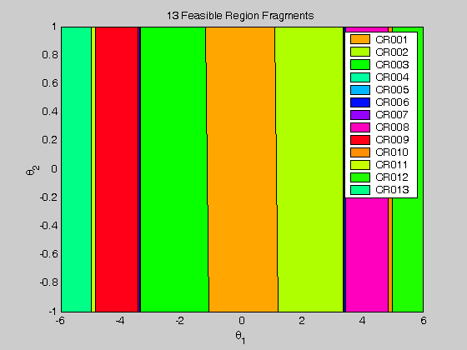
Map of Critical Regions
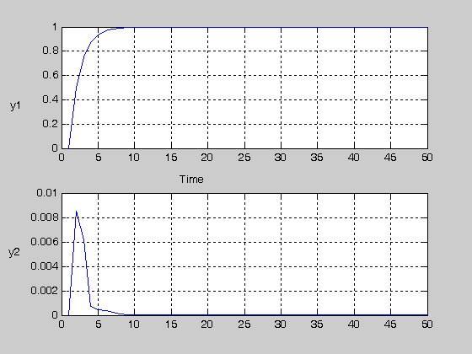
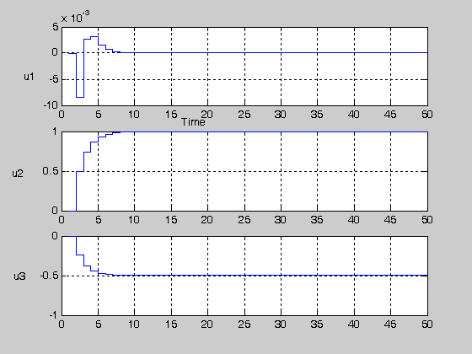

POP manages to control output 1 but not the input variables. (we were expecting that since Q_{R}>>R)
If we alter the tuning parameters in the following values:
mpc.Q = 1*[1 0;0 0]; % scaling for states
mpc.R = 0.00001*eye(3);% tuning for uref!
mpc.R1 = 0.1*eye(3);
mpc.QR= 10.5;
mpc.R = 0.00001*eye(3)+ [0 0 0; 0 100 0; 0 0 0];% tuning for uref

There is a significant difference in the results.
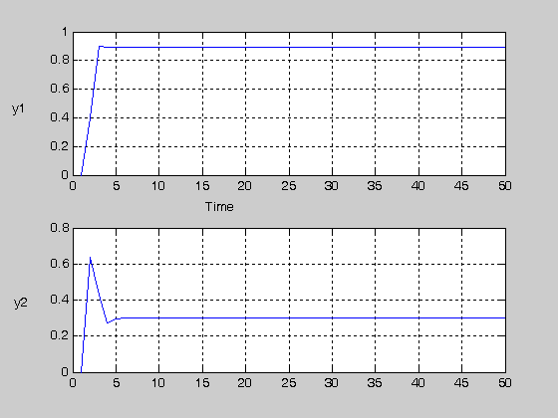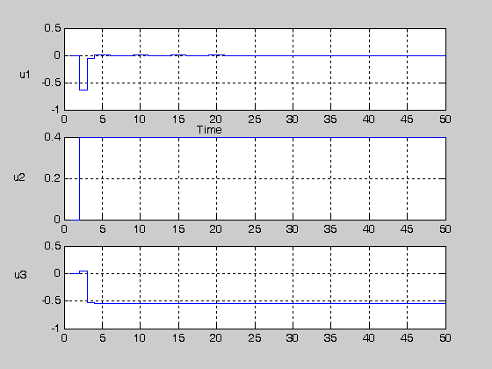

Although the controller manages to keep the value of u₂ to 0.4(desired value), y1 moves away from value 1.

